AD23532 – PRINCIPLES OF DATA SCIENCE
EXPERIMENT 2: DATA DISCOVERY AND PREPARATION

QUESTION:
A telecommunications company has observed an increase in customer churn, leading to revenue loss. Analyze the Telco Customer Churn dataset to discover meaningful insights, identify data quality issues, detect outliers, visualize customer behavior, and prepare the dataset for predictive analytics.

AIM:
To perform data discovery and exploratory data analysis on the Telco Customer Churn dataset by analyzing customer distributions, visualizing numerical features, detecting outliers using the IQR method, identifying relationships between variables, answering analytical questions, splitting the dataset into training and testing sets, and saving the preprocessed dataset as a CSV file.

ALGORITHM:
- Import the required Python libraries: Pandas, NumPy, Matplotlib, Seaborn, and Scikit-learn.
- Load the Telco Customer Churn dataset into a Pandas DataFrame and display its basic information and summary statistics.
- Analyze the distributions of Customer Churn, Gender, Contract Type, and Payment Method using count plots.
- Visualize MonthlyCharges, TotalCharges, and Tenure using histograms and box plots.
- Detect outliers in numerical features using the Interquartile Range (IQR) method.
- Create count plots, box plots, histograms, and scatter plots to analyze relationships between Contract Type, Internet Service, Monthly Charges, Tenure, and Churn.
- Analyze churn patterns, frequently used payment methods among churned customers, average tenure, monthly charges, and customer groups with higher churn.
- Split the dataset into 80% training data and 20% testing data.
- Save the prepared dataset as CustomerChurn_Preprocessed.csv.

PROGRAM & OUTPUT:

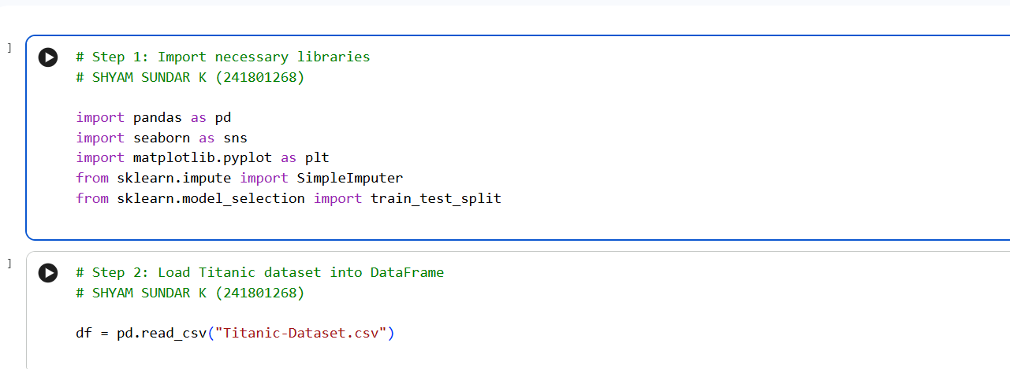
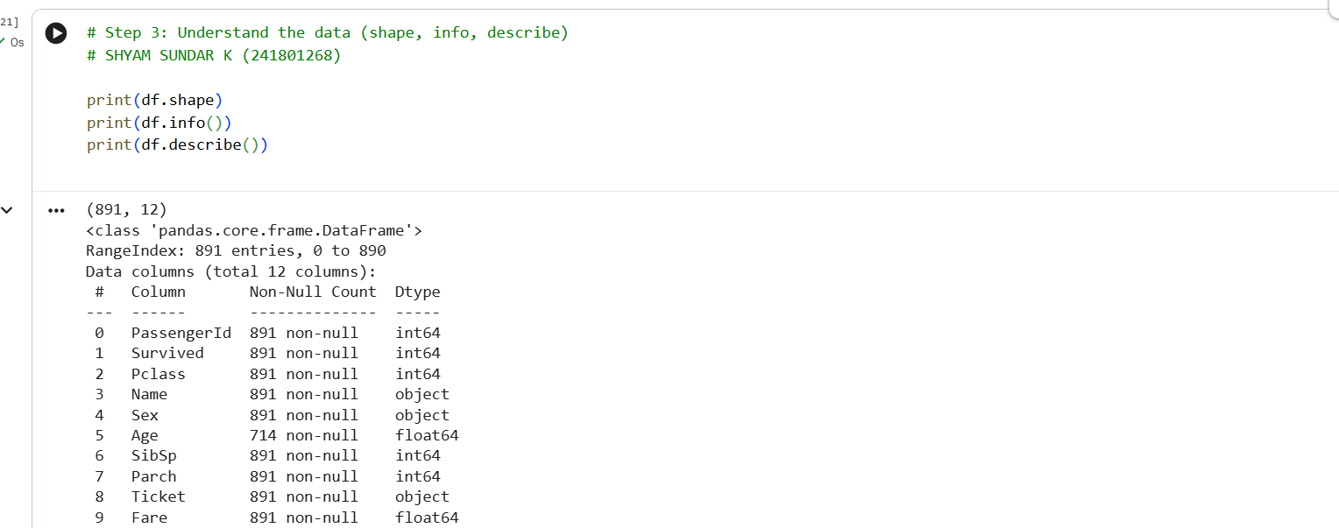
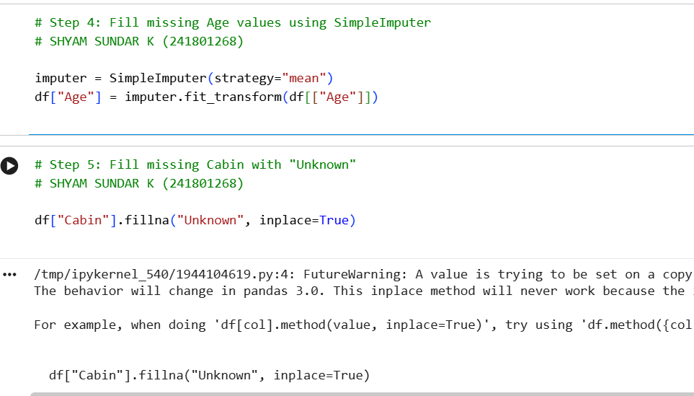
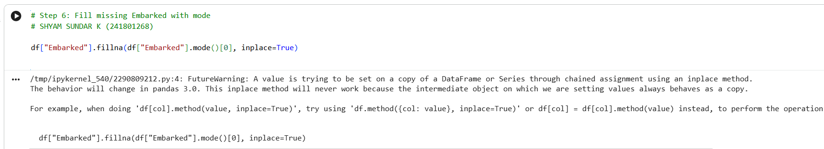
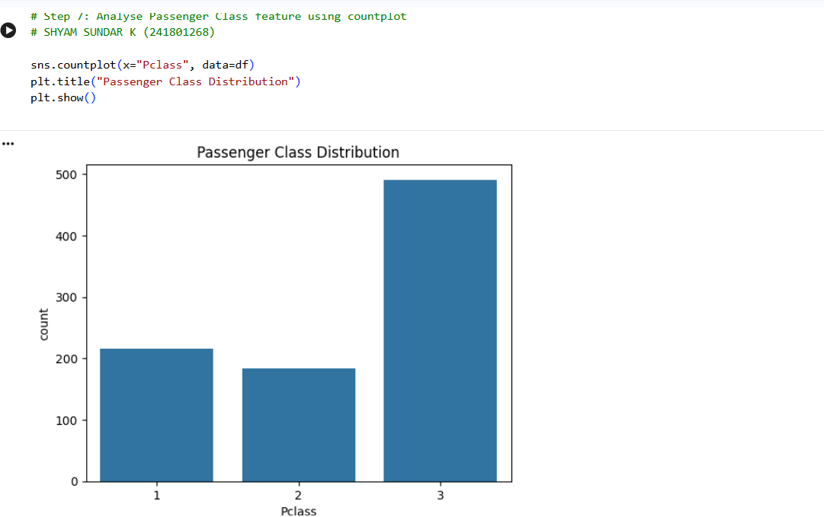
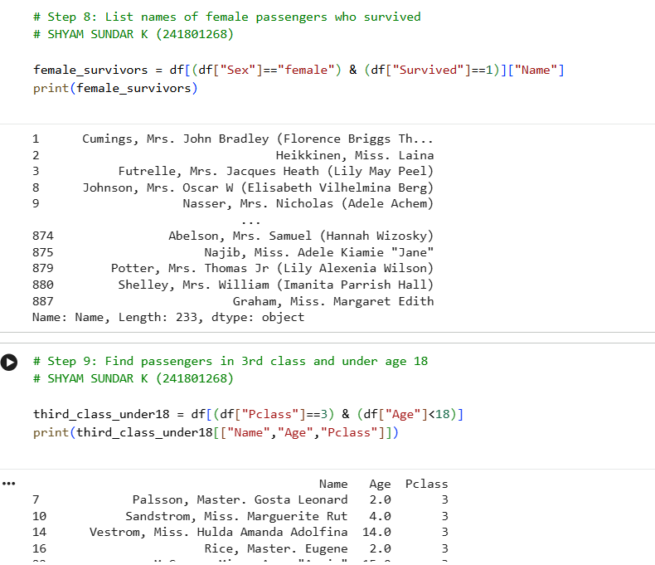
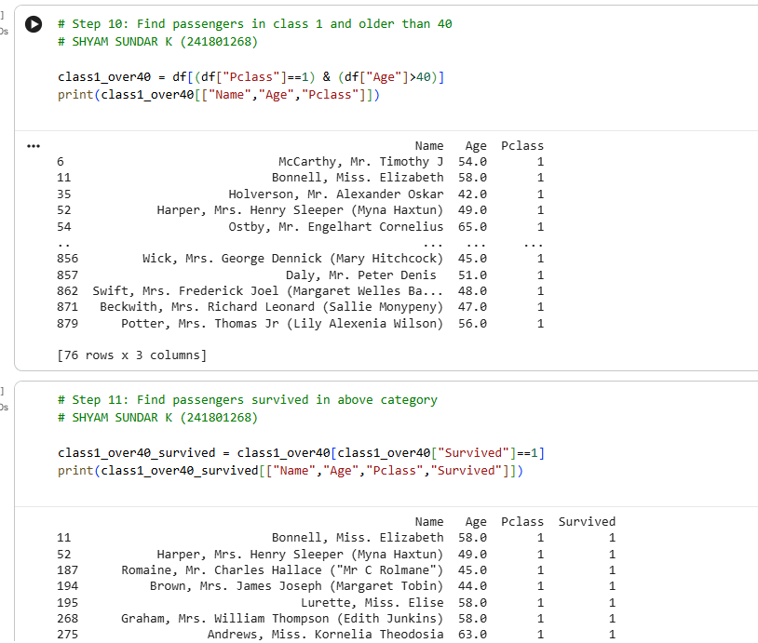
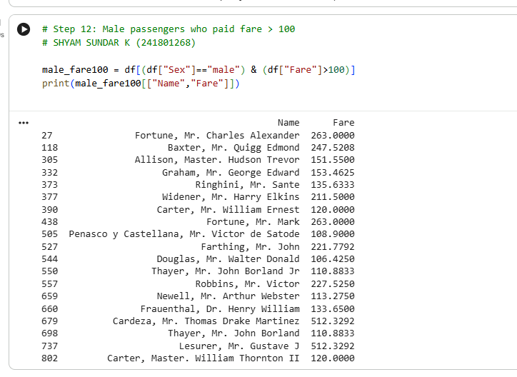
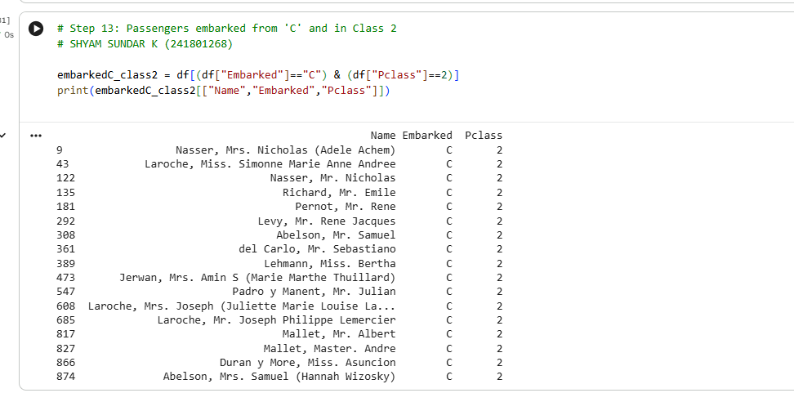
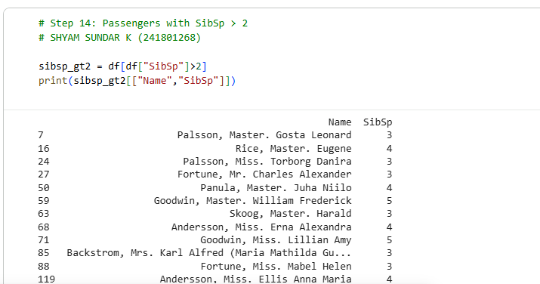
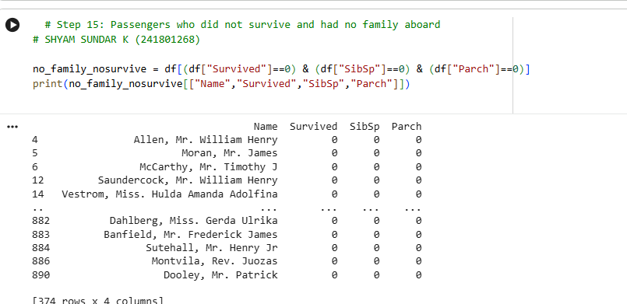
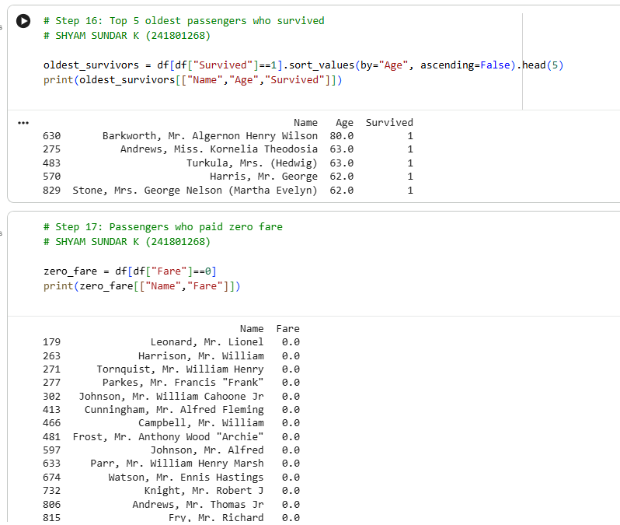
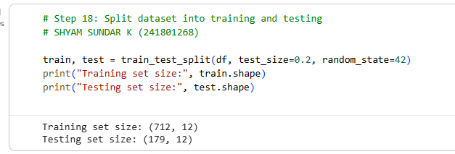

RESULT:
Thus, data discovery and exploratory data analysis were performed successfully on the Telco Customer Churn dataset. Customer distributions were analyzed, numerical outliers were identified using the IQR method, and visualizations were generated to study relationships between customer features and churn. The dataset was split into 80% training data and 20% testing data, and the prepared dataset was saved as CustomerChurn_Preprocessed.csv.

